# Project Name: Adding a New Product in the Database

# Output:

### Landing Page:

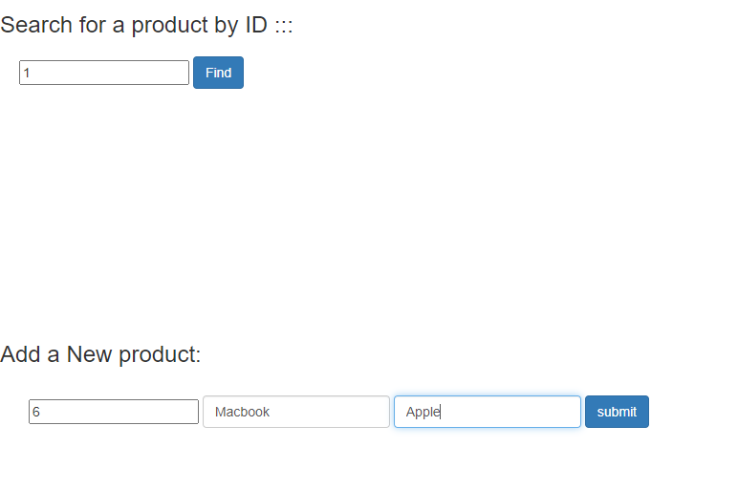

### Adding a new Product:

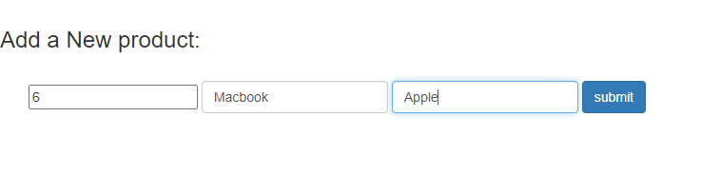

### After successful addition:



### Show record from the database: